Exploring Calculus I with Maple

Glendale Community College
Mathematics Department
by
Nadine Moore
Craig Chamberlin

Introduction 2

Lab 1: Introduction to Maple 7

Lab 2: Functions, Expressions and Limits 18

Lab 3: Spreadsheets in Maple 25

Lab 4: Evaluating Limits in Maple 31

Lab 5: Secants and Tangent Lines 35

Lab 6: Derivatives in Maple 41

Lab 7: Implicit Relationships 46

Lab 8: Linear Approximations and Differentials 51

Lab 9: Graphing Using Derivatives 57

Lab 10: Numerical Integration 63

Lab 11: Integration in Maple 70

INTRODUCTION

This manual was developed by the mathematics department at Glendale Community College (Glendale, Arizona) for the purpose of integrating the computer software package Maple 6.0 into the Calculus I course. The labs were written in Maple 6 and were designed to run off GCC’s network. Each lab in the manual contains examples to demonstrate the Maple commands needed to investigate some calculus concept. Each lab also contains an assignment for students to complete by using Maple. This manual does not contain any formal programming. The labs assume no prior knowledge of Maple. The online version contains executable examples; there are also some animated demonstrations that are not in this manual.
Maple is a powerful software tool for mathematical computations and visualization. Our focus is on the use of Maple as a tool to investigate problems that would be difficult or tedious to be done by hand.

GETTING STARTED ON MAPLE

Students run Maple from their palette account: a user ID and password are needed. At one of the Palette Account Stations at the west ends of HT1 or HT2 or at the Library Media Center, students can check their user ID and password and pick up instructions for the Instructional Palette.

Login Instructions.
Turn on the computer. When the login box appears, enter your user ID in the name box and password in the password box. If this is the first time that you have logged into GCC’s computers, your initial password frequently is your social security number; you will be asked to change your password – the new password must contain at least six characters.

Instructions to run the software Maple.
Use the mouse to place the arrow (cursor) on the “Start” button in the lower left corner. Hold down the left button on the mouse and move up to highlight “Programs”; move the arrow right to “math software”
and then to “Maple 6”. Click on “Maple 6”. After a short time, the Maple worksheet will appear and you are ready to enter Maple commands.

Instructions to run the Maple labs for Calculus I.
The Maple labs in this manual are already on GCC’s network. To run one of these labs from the main menu double click on each of the following: “my computer” icon, “Courses on ‘Gecko’ ” , “Calc I Labs”, then “Exploring Calculus I”. An alternate way to run the labs is as follows: open Maple. Then click on “File”, “Open”. In the “Drives” box choose “s:\\Courses on ‘Gecko’ ” , then “Calc I Labs” and “Exploring Calculus I”.

Instructions when you are finished running Maple
Exit Maple by clicking on the big “X” in the upper right corner of the screen or use the menu “File”, “Close”. Shut down the computer: click on “Start”, “Shut Down”, “yes”.

BASIC MAPLE COMMANDS

Maple, like computer programming, is very sensitive to syntax.
Maple distinguishes between upper and lower case letters. A variable must always be entered in the same case. Certain commands change when the case of the command is changed.
Maple has two keys for input modes on the tool bar:

T
is for text mode – these lines are ignored by Maple.

[>T

[>T
is for command mode – these lines are executed by Maple. The

icon can also be used to insert a command line below the current line.
Help on the syntax of any Maple command can be obtained by typing ?command
Each Maple command must end with a semicolon or a colon.
Maple distinguishes between expressions and functions. Commands for expressions and functions are different – see table below.

 | Expressions | Functions
Example: | f:=3*x^2+2*x-5;  Do not use f(x) for the name of an expression. | f:=x3*x^2+2*x-5;  To enter use the minus key –  followed by the greater than key >
Evaluating f at x =a | subs(x=a,f ); or  eval(f,x=a); | f(a);
Graphing y = f(x) where the screen dimensions are and . If the x’s or y’s are not specified, Maple uses  the default values ; the range is usually chosen by Maple to be the maximum range for the x-values of the graph. | plot(f,x); plot(f,x=a..b); or  plot(f,x=a..b,y=c..d);  Maple does not like  plot(y,x=a..b,y=c..d) where y is used as the expression name; names such as f, g,.. are better for  expressions. | plot(f); plot(f,a..b); or  plot(f,a..b, c..d)  Do not include x= and y=
First derivative | diff(f,x); | D(f);
Second derivative | diff(f,x$2); or diff(diff(f,x),x); | (D@@2)(f); or D(D(f));
Indefinite integral | int(f,x); | int(f(x),x);
Definite integral | int(f,x=a..b); or  Int(f,x=a..b); to display integral,  followed by value(%); to compute the value | int(f, a..b);
 | limit(f,x=a); | limit(f(x),x=a);
 | limit(f,x=infinity); | limit(f(x),x=infinity

Note (1) If f is defined as a function, f(x) is an expression; the commands for expressions can be used if f is replaced by f(x).
Note (2) If f is defined as an expression, the command f:=unapply(f,x); turns f into a function.
Do not use the f(x) notation when f is defined as an expression.

MORE GRAPHING COMMANDS
plot(expr, x, scaling=constrained); plots expression, expr, over the default interval
using the maximum range of y’s, but adjusting the x-scale to correspond to the scale given for y so that there is less distortion.
plot({exp1,exp2},x); plots the graphs of expressions, exp1 and exp2, on the same coordinate axes.
plot([exp1,exp2], x, color=[black,red]) plots exp1 in black and exp2 in red.
plot([f(t), g(t),t=a..b]); plots the graph of the parametric equations x = f(t) and y = g(t) for .
plot(f, x, style = point); plots an expression y=f(x) point by point. Use this for discontinuous functions so that the breaks are not connected. If more points are desired, add numpoints=200 inside the parentheses to have Maple plot 200 points .

ALGEBRAIC COMMANDS for expressions, expr.
evalf(expr); evaluates a numerical expression as a floating point number.
expand (expr);
Examples: expand(numerical expr); evaluates a numerical expression as a floating point number.
expand(x^2*(2*x+1)^3); does the multiplication.
expand(sin(x+y)); produces the formula sin(x)cos(y)+sin(y)cos(x).
expand(exp(2*x)); produces the product .
factor(expr); factors a polynomial expression.
simplify(expr); simplifies the expression.

REFERRAL TO PREVIOUS OUTPUT
% refers to the output of the previous command.
evalf(%); evaluates the previous output as a floating point number.
value(%); computes the value of the previous output.

EQUATIONS

solve(equation,x); tries to give a exact solution listing all x’s which solve the equation. If the equation is a polynomial of degree three or more, the solution may be expressed as ‘RootsOf’. Maple may not know how to find exact solutions. If this command is followed by evalf(%);, the floating-point decimal solutions are found. Maple may not list all solutions; for example, when trigonometric functions are involved.
a:= solve(equation,x); seeks the solutions. If there is more than one solution, the solutions will be called
a[1], a[2],…
fsolve(equation,x=a..b); seeks floating point decimal solutions to the equations using x’s in the interval
[a,b]. Frequently Maple only finds some of the solutions. Restricting the interval on which Maple searches will help it to find the other roots.
solve({eqn1, eqn2}, {x,y}); tries to give the exact solutions x and y to the system of simultaneous
equations labeled eqn1 and eqn2. assign(%); assigns the values found for x and y to those
variables.
rhs(eqn); and lhs(eqn); reads off the right and left sides of an equation, eqn.
implicitdiff(eqn,y,x); finds the derivative .
with(plots); followed by implicitplot(eqn, x=a..b, y=c..d); plots the equation.
NUMERICAL INTEGRATION of an expression, expr
Sum(expr,i=m..n); displays . If this command is followed by value(%); or evalf(%);,
the sum is evaluated.
To approximate using n equal subdivisions of [a,b] use the following commands preceded by
with(student);
rightbox(expr, x=a..b, n); plots a graph of expr and n rectangles formed by using the right
ends of the subintervals.
rightsum(expr, x=a..b, n); gives the sigma notation for rightbox. If this command is
followed by value(%); or evalf(%);, the sum is evaluated.
leftbox(expr, x=a..b, n); plots a graph of expr and n rectangles formed by using the left ends
of subintervals.
leftsum(expr, x=a..b, n); gives the sigma notation. If this command is followed by value(%);
or evalf(%);, the sum is evaluated.
middlebox(expr, x=a..b, n); plots a graph of expr and n rectangles formed by using the
midpoints of subintervals.
middlesum(expr, x=a..b, n); gives the sigma notation. If this command is followed
by value(%);or evalf(%);, the sum is evaluated.
trapezoid(expr,x,a..b,n); approximates by using n-trapezoids.
simpson(expr,x,a..b,n); approximates by using Simpson’s Rule.

RATIONAL EXPRESSION, expr
normal(expr); puts the expression in the form numerator/denominator.
numer(expr); reads off the numerator.
denom(expr); reads off the denominator.
quo(p,q,x); is the quotient when p is divided by q.
rem(p,q,x); is the remainder when p is divided by q.

MATH SYMBOLS | MAPLE
 | Pi
 | exp(x)
 | sqrt(2*x+1)
surd(x,3)
x^(1/3) will not evaluate for negative x’s
sin x | sin(x)
, an inverse trig. function | arcsin(x)
 | log[2](x)
[[x]] the greatest integer function | floor(x)
f:=piecewise(x<3, 2*x, 5-x)
an expression

COMMON ERRORS IN MAPLE

Maple distinguishes between upper case and lower case letters.
Punctuation must be entered and be correct.
Each Maple command must end with a semicolon or a colon.
Multiplication requires an asterisk. Examples: is entered as 3*x^2+4*x; (x+1)(x-2) is entered as (x+1)*(x-2).
Parentheses should come in pairs. Example: is entered as (x+2)/((x+3)*(x-4)).
is entered as (sin(x))^2.
Arguments of functions must be contained in parenthesis: sin(x), not sin x….
Maple distinguishes between exact and approximate calculations. A decimal point is enough is cause Maple to use approximate arithmetic. Example: factor (x^2-1); will run; factor(x^2-1.); will not run.
Variables can be used to store results. The assignment operator is “:=”, not just equal.
Maple holds in memory all old variable assignments. Maple’s memory can produce unexpected results. A value stored in variable, x, can be cleared with the command x=‘x’;. The command restart; clears all variable values.
There will be times when Maple does not produce the right result or refuses to execute a command even when the correct commands are given.
1. Use the command restart; or 2. quit Maple and start over.
When you are working on a problem, save the work after every few commands in case the session
is interrupted. Otherwise, you may lose work and be forced to start all over.
When opening or editing a worksheet, re-execute every command. Maple is not like word processing software where you can start in the middle. Maple needs to recall every command starting with the first one.
If you forget the exact syntax of a command, you use Help on the toolbar or enter ?command
Graphs can be plotted within the worksheet or in their own separate window – see Option, plot display.
When plotting a graph change the screen size if the curve seems strange or does not appear on the screen. Maple’s default domain and range may not show the important features of the graph.
Sometimes a command will not execute because it is part of one of Maple’s library packages. The library package containing the command must be loaded into a Maple session before the command can be used. Example: with(plots); must be entered before you can use implicitplot. If you forget that implicitplot is part of a library package, enter ?implicitplot; ; Maple will indicate that implicitplot is part of the plots package.
Maple distinguishes between expressions and functions.
Lab 1: Introduction to Maple

Goals
Students will use the appropriate Maple commands to perform the numerical, algebraic, and graphical exercises given below.

Discussion
For every lab in this manual, we provide examples of the Maple commands (in bold print) that you will need to complete the questions that follow. Read through the following worksheet carefully, taking notes on the commands that are demonstrated so that you can complete the activity at the end. Please keep in mind that this lab manual is essentially a hard copy of the Calculus I computer labs found on the Student Palette, and therefore it is written as if the reader were on the computer working through the lab.

Input Modes
Maple has two main input modes: command and text. In order to execute a calculation, Maple must be in command mode. The [> symbol next to the cursor on the computer screen indicates that Maple is in command mode. To put Maple in command mode, click the [> button on the tool bar and then type your command next to the [> symbol that appears on your screen. Note that, in this lab manual, each example of Maple input is indicated by the ">" symbol. For each input, the output (answer) is displayed on the following line.

In order to write an explanation to a lab question, Maple must be in text mode (so that it acts like a word processor). To put Maple in text mode, click the T icon on the tool bar.

Numerical Calculations
At its most basic level, Maple is a very powerful calculator. You can use the following arithmetic operations: +, -, *, /, ^ which are addition, subtraction, multiplication, division, and raising to a power, respectively. For example, to calculate (32)() you would type the following and press the Enter button on the keyboard:

> 32*12^13;

The output is the above number in the center of the paper, 3423782572130304. Note that each command is followed by a semicolon. Also observe that you must use "*" to tell Maple to multiply.

Maple uses the standard order of operations. To be sure that operations are performed in the desired order, use parentheses. The next two samples of Maple input and output demonstrate the use of parentheses with regard to order of operations.

> (2+4)/7;

> 2+4/7;

Be sure to use round parentheses rather than square brackets [ ] or curly braces { }, which have other meanings in Maple.

To calculate (2+3)(3-1), enter the command
> (2+3)*(3-1);

Note that the multiplication operator * is required.

Maple recognizes a wide variety of special operators including factorial, greatest common divisor, and least common multiple. The following input is an example of the factorial operator in use.
> 200!;

The expansion of 200! is shown above.

You can easily include the previous expansion of 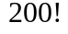 in any subsequent calculation without having to type it. The ditto operator, represented by a percentage sign (%), refers to the last expression computed by Maple. The command ifactor, which is only used to factor numbers, factors the previous result into its prime factorization.

> ifactor(%);

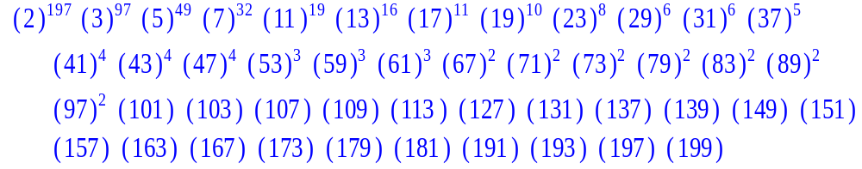

The next command calculates the product again, which is precisely the value of 200!.
> expand(%);

A principal strength of Maple is its ability to do exact arithmetic. Fractions and radicals are not immediately converted to their decimal equivalent, thereby avoiding round-off errors. When you need to use decimal equivalents, Maple has a command that approximates the value of the expression in a decimal floating-point form.
Consider the expression , which is entered on the Maple command line as follows.
> (2^30/3^20)*sqrt(3);

Using the evalf command, you can generate an approximation in the form of a decimal floating-point value.
> evalf(%);

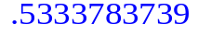

Help
If you ever need additional information with a Maple command, ask for help by typing in a question mark followed by the Maple command and then press Enter. For example, type in ?+ and then press Enter. A help window will open that gives information on the various arithmetic operations that are available in Maple. You can also open up the help menu by clicking on the "Help" option on your tool bar. When you click on “Help,” a menu scrolls down with many options. The "introduction" will give you a grid of topics, and the "topic search" allows you to type in certain word items that you may need.

Assigning Variables
Names or labels can be used to store and refer to results. Assignment statements use the colon-equal symbol ":=''
> A := 5;
> A;

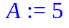
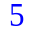
This means that the variable "A'' has been assigned the value 5 and it will retain this value through the remainder of the session unless you assign it another value or "unassign" it.

> 4*A+12;

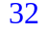

The following statement is the way to "unassign" the variable.
> A := 'A';
Note that in the last command statement we have enclosed A within two single quotes.

Maple Constants and Maple Built-in Functions
Maple has many of the standard mathematical constants built-in. Maple is also "case sensitive" , which means that it treats "a" and "A" as distinct symbols. The mathematical constants (the ratio of the circumference of a circle to its diameter), and i (the pure imaginary number such that = -1) are denoted by "Pi," and "I" respectively. The following commands are employed to evaluate to 9 and 50 places past the decimal, respectively.
> Pi;
> evalf(%);
> evalf(%%,50);

Maple also has many built in functions. Trigonometric functions, , square root, etc. are all functions that Maple has built in to its system. Let's calculate the sine, cosine, tangent, cosecant, secant, and cotangent of 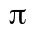.
> sin(Pi);cos(Pi);tan(Pi);csc(Pi);sec(Pi);cot(Pi);

Error, (in csc) numeric exception: division by zero

Error, (in cot) numeric exception: division by zero

Note the following items: (1) The trigonometric functions use the same notation that you use. (2) The argument for the trigonometric function has to be in parentheses. (3) Maple calls division by zero a singularity. (4) You can enter several execution statements into one line.
Now let's evaluate 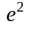.
> exp(2);

Note that the Maple command is exp and that the power has to be in parentheses. To get a decimal approximation of , use the evalf command:
> evalf(%);

Use the following commands to evaluate the square root of 2 as a decimal.
> sqrt(2);

> evalf(%);

See the Maple “Help” menu for other built-in functions.

Algebraic computations

Expanding and Factoring Expressions

Maple can expand binomials such as . The following Maple commands create the expression, and then expand it.
> expr := (x+y)^15;

> expand(expr);

Note that in the above example, we first defined the expression, "expr." We can also expand directly.
> expand((x+y)^15);

After viewing the result, you can use the factor command to factor it in order to check the computation.
> factor(%);

Simplifying Expressions

Maple can apply identities to simplify many lengthy mathematical expressions, such as trigonometric expressions. For example, we can use the simplify command to simplify as follows.

> simplify(cos(x)^5 + sin(x)^4 + 2*cos(x)^2 - 2*sin(x)^2 - cos(2*x));

Another way to simplify expressions is to use the normal command, which puts fractions on a common denominator and removes common factors in the numerator and denominator. In the next example, the fraction 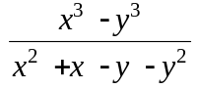 is simplified after Maple removes the common factors.
> normal( (x^3-y^3)/(x^2+x-y-y^2) );

Assigning Variable names

The use of variables is essential for managing large numbers of expressions and functions, especially if you want to reuse the output later in a session.
For example, define an expression, such as , and store it as "expr1."

> expr1 := (41*x^2+x+1)^2*(2*x-1);

The next command shows how to use the expand command on and store the result as a variable, .
> expr2 := expand(expr1);

You can evaluate at x = 1 by using the eval command as follows.
> eval(expr2 , x=1 );

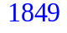

The subs command can also be used to evaluate expr2 at x = 1.

> subs(x=1,expr2);

Solving Equations

Algebraic equations

In the next example, we use Maple to solve the equation 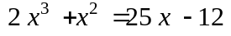 .
> eqn := 2*x^3+x^2 = 25*x-12;
> solve( eqn, {x} );

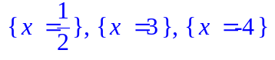
To verify that this is a solution, evaluate the equation at a particular value of x.
> eval( eqn , x=3);

You can also solve the equation directly.
> solve(2*x^3+x^2 = 25*x-12,x);

Systems of equations

You can also solve systems of equations in Maple.
Consider the following set of three equations and three unknowns:
> eqn1 := x+2*y-2*z=-2;
> eqn2 := 5*x+9*y-4*z=-3;
> eqn3 := 3*x+4*y-5*z=-3;

Next, we solve the system for the variables , , and .

> solve( {eqn1, eqn2, eqn3}, {x, y, z} );

To verify that this solution satisfies, say eqn1 and eqn2 , evaluate both of them at this solution as follows.
> eval( {eqn1, eqn2} , % );

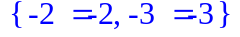

Graphics
The following examples generate and refine the graph of .

> plot(x^2,x);

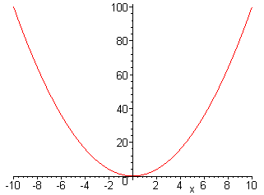

> plot(x^2,x=-5..5,y=0..25);

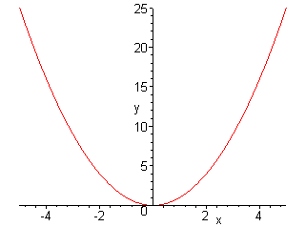

Note that in the last graph, the domain and range were specified.

The next example demonstrates how to plot more than one function on the same plane. We first define two new functions (as Maple expressions).

> m:=x^3-9*x^2+26*x-24;

> n:=3*x^2-11*x+6;

> plot({m,n},x=-1..8);

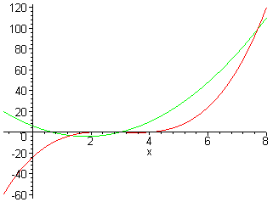

We can find the x-coordinates of the points of intersection of m and n using the solve command.
> solve(m=n,x);

We can also find decimal approximations of the intersections using fsolve.
> fsolve(m=n,x);

Next, we find the y-coordinate associated with intersection coordinate of x = 3.
> eval(m,x=3);

Thus, (3,0) is a point of intersection between the graphs of m and n.

Lab Assignment 1

Do your lab in a new file (go to the file menu and click on "New"). Copy and paste the below questions to your new file. Be sure to start your lab by putting your name on the first line. Here's a way to do that: Look at the icon bar at the top of the screen and you will see a T button in the center. Clicking on that T puts you in text mode (i.e. you can write whatever you want and Maple will ignore it.) Clicking on the arrow button just to the right of the T lets you return to calculation mode (i.e. Maple knows to evaluate lines that start with this arrow). Use Maple to answer the questions. ANSWER ALL QUESTIONS COMPLETELY IF YOU WANT FULL CREDIT!!! When you complete the lab, hand in a printout of your worksheet.

1. Expand the following expressions.
a)
b)

2. Factor: 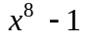

3. Add the following rational expressions by applying the simplify command:
.

4. Input the following polynomials: and (for
example, assign the polynomial the name p). Next, graph the
polynomials on the same coordinate axes. Adjust the domain and range appropriately
so you can estimate the intersection points of the polynomials. What is an
approximation for the points of intersection?

5. Find the roots (a.k.a. the zeros) of the polynomial q by setting q equal to zero and
applying the solve command.

6. Estimate the points of intersection of the two polynomials defined above using the
fsolve command to find the x-coordinates and eval or subs to find the
corresponding y-coordinates.

7. Find the value of correct to 100 places past the decimal.
Lab 2: Functions, Expressions, and Limits

Goals
1. Students will apply the appropriate Maple commands to define, evaluate, and graph
Maple functions and Maple expressions.
2. Students will evaluate limits using Maple.

Discussion
There are two ways to input mathematical functions into Maple's memory. The first is to define the function as what Maple calls an expression. The second method is to define the function as what Maple calls a function. The commands for functions and expressions are different. If Maple will not execute your command, check that the input mode (function or expression) and the command mode are the same.

Functions and Expressions
The following is an example of how to define the function as a MAPLE EXRESSION.
> f:=x^2+2*x+3;

To evaluate an expression at x = 2 use one of the following commands.
> eval(f,x=2);

> subs(x=2,f);

Do not use f(2). Maple reserves this notation for functions.

The following shows how to define the function as a MAPLE FUNCTION.
> f:=x->x^2+2*x+3;

The "" symbol is created by the minus sign followed by the greater than sign. Now the standard function notation, f(2), is used to evaluate the function f(x) at x = 2.
> f(2);

When f is defined as a function (using x), Maple recognizes f(x). When f is defined as a expression (with no x ), Maple thinks f(x) is nonsense.

The Relationship Between Functions and Expressions
If you have defined f as an expression, you can convert it to a function by using the unapply command. The following example shows how to turn the expression f into a function g and how to evaluate both f and g at x = 3.
> f:=x^2+3;

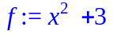

> g:=unapply(f,x);

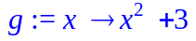

> g(3);

> eval(f,x=3);

If you have defined g as a function in Maple, you can get Maple to think of g as an expression by entering g(x). For example, consider the following function.
> g:=x->cos(x);

Use g(x), as opposed to just g, in the Maple commands that require expressions. For instance, to use the eval command (which works only with expressions), enter the following.
> eval(g(x),x=Pi/4);

Note that if you had entered "eval(g,x=Pi/4);", Maple would have not performed the desired command.

Maple Commands
The commands for graphing functions and expressions are slightly different. The following example demonstrates how to get Maple to plot a Maple expression.

> f:=x^2-4;

> plot(f,x=-5..5,y=-10..25);

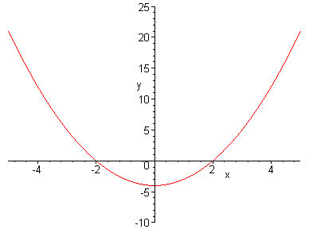

Note that, when f is defined as an expression, the "x =" and "y =" are included when specifying the domain and range. To plot a function g (see the following example), do not include "x =" and "y =".
> g:=x->x^2-4;

> plot(g,-5..5,-10..25);
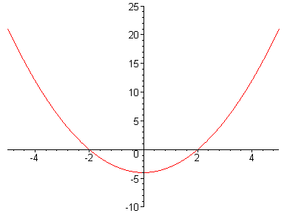

The Maple commands evalf, expand, simplify, and factor require expressions for arguments.
> factor(f);

> factor(g(x));

> factor(g);

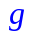

The last command above failed to work because g is not defined as a Maple expression.

Limits
We will investigate the following limit: 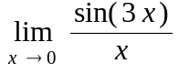 .
> f:=x->sin(3*x)/x;

> plot(f,-1..1);

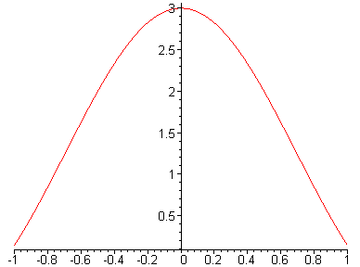

> f(0);

Error, (in f) division by zero

Note that, although the function f is undefined at x = 0, we can still investigate f(x) when x is close to 0. Consider the above graph. What is f(x) close to when x is close to zero but not quite equal to 0? Let's calculate some values for f(x) when x is close to 0.
> f(0.1); f(0.01); f(0.001);

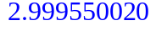

> f(-0.1); f(-0.01); f(-0.001);

It appears that f(x) approaches the value of 3 as the x approaches 0.
Let's see how Maple evaluates limits using the limit command.
> limit(f(x),x=0);

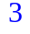

Discontinuous Functions
Let f(x) be the following piecewise-defined function.
> f:=x->piecewise(x<2,x^2,2*x+3);

> plot(f,-5..5,numpoints=200,style=point);

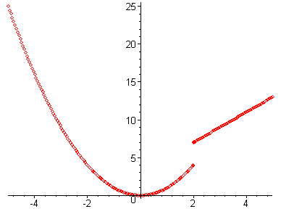

We use "style=point" above to prevent Maple from connecting points that should not be connected. Let's have Maple do the left-hand and the right-hand limits of f as x appoaches 2.
> limit(f(x),x=2,left);

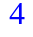

> limit(f(x),x=2, right);

> limit(f(x),x=2);

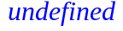
The two-sided limit does not exist since the left-hand limit is different from the right-hand limit.

Next, let's make Maple plot the greatest integer function [[x]].
> f:=x->floor(x);

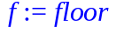
> plot(f,-5..5,numpoints=200,style=point);

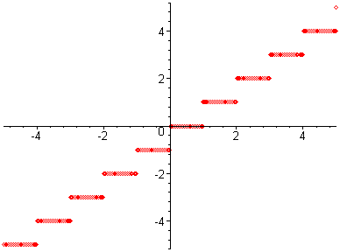

> limit(f(x),x=2,left);

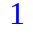

> limit(f(x), x=2,right);

Lab Assignment 2

Start the lab by putting your name on the first line. Do the assignment in a new file (go to the file menu in Maple and click on "New"). Copy the below questions to your new file. When you complete the lab, hand in a printout of it. ANSWER ALL QUESTIONS COMPLETELY IF YOU WANT FULL CREDIT!!!

1. a) Graph the function 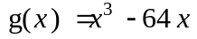 by defining g as a function in Maple.
(Note that a 10 by 10 viewing window is inappropriate for this function.
Define your domain and range so that you can see all of the "peaks" and
"valleys" of this graph.)

b) Use Maple to find g(-2.35).

2. a) Graph , by defining f as an expression in Maple .

b) Use Maple to find f(231.2).

3. a) Graph f(x) = , by defining f as a function in Maple and using the
domain [-0.2, 0.2].

b) We wish to find 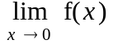. Use Maple to find f(x) for
x = +0.1, +0.01, +0.001, and +0.0001.

c) Use Maple's limit command to find the limit.

4. a) Graph f(x) = cos(1/x) as a function in Maple with domain [-0.2, 0.2].

b.) Use Maple to find f(x) for x = +0.1, +0.01,+0.001, and +0.0001.

c.) Use Maple's limit command to find 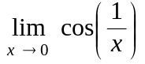.

d.) Is Maple's limit in part (c) reasonable? Why or why not?
What should you say about ? Explain your answer.

Lab 3: Spreadsheets in Maple

Goal
Students will create spreadsheets in order to help them evaluate limits.

Spreadsheets
We use spreadsheets in Maple to create tables of values. To insert a spreadsheet, click on "Insert" and from there choose "spreadsheet" (see the picture below).

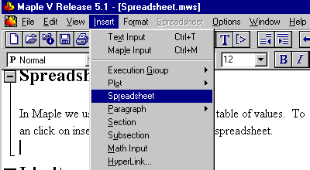

The following example demonstrates how to create a spreadsheet in Maple. This particular table will illustrate that 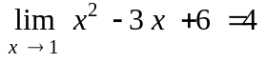. To label the columns in your spreadsheet, click on the box where you want to put your label, for example box A1. Next type in a single quote followed by your label and ending with a single quote and then press the Enter key. What you type in will show up near the top of the window, as shown in the figure below.
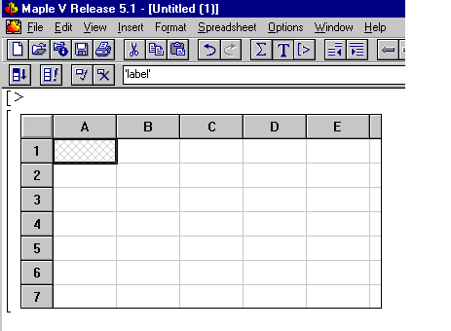

Notice the word 'label' above (with the single quotes included). After you press the Enter key the word "label" will appear in the A1 box in the spreadsheet.

Now we are going to create a table in Maple. Be sure to make this table in a new file.
Whenever you want to work with functions, expressions or variables in your table, they have to be in Maple's memory before you create the table. Execute the following commands in your Maple worksheet that you have just started (DO NOT EXECUTE THESE COMMANDS IN THIS WORKSHEET!!).

> f:=x->x^2-3*x+6;
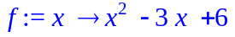
> delta:=1;
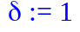
> a:=1;
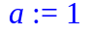

After executing the above commands in the new file, click on "Insert" then "Spreadsheet."

Put the following labels on your spreadsheet: column 1 'delta', column 2 'a +delta ' and column 3 'f(a +delta)'. Don't forget to put single quotes around your entries.

Now type "delta" in box A2, press Enter, and then type (a + ~a2) in box B2, press Enter, and last type evalf(f(~b2)) in box C2 and press enter. Notice you should have the numbers 1, 2 and 4 in these three boxes. Also observe that whenever you refer to a cell in your spreadsheet, you need to put a "~" before the name of the cell.

Here is what your spreadsheet should look like now.

 | A | B | C | D | E
1 |  |  | 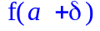
2 |  | 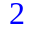 | 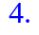
3
4
5
6
7

Next, type the following in box A3: evalf(~a2/2) and then press Enter.

If you wish to fill in the rest of the table with the pattern set in place in boxes A3 and B2, here is what you do.
1.) Click and hold down the left mouse button on box A3, the one you want to pattern the rest of the boxes after in column 1, and drag down as far as you wish to go in order to highlight the column. For example, highlight the column down to box A10.
2.) Then click on the upper left button that looks like this:

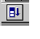
Next, do the same with B2, dragging down to box B10 and C2 dragging down to box C10. Your spreadsheet should now look like the figure below.

 | A | B | C | D | E
1
2
3 |  |  | 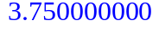
4 | 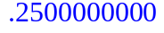 | 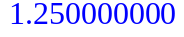 | 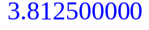
5 | 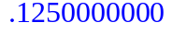 | 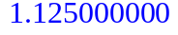 | 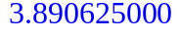
6 | 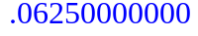
7
8
9
10
11

Notice that the table is set up so that the -values in column A are getting closer to zero from the right, which in turn means that the values in column B are getting closer to a = 1 from the right. So the values in column C are approaching . This limit appears to be about 4.

The next table investigates 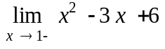.

 | A | B | C | D
1 |  | 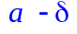
2
3
4 |  |  | 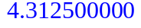
5
6 |  |  | 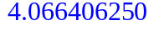
7 |  | 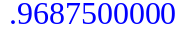 | 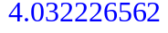
8
9
10 |  |  | 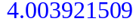

From this table, it appears that 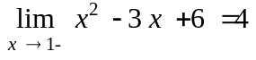. Thus, since the left and right limits seem to the same, we can be fairly confident that .

Example: Now, suppose we want to use the above tables to approximate a number 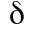 so that, for 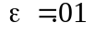, 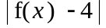< whenever <. To do this, look at the values underneath the column "f(a+)" and "f(a-)" in both tables and notice that the values 3.992248535 and 4.007873535 are both within .01 units of 4. These two numbers correspond to a of about 0.0078. So, based solely on the tables, the largest value of that will satisfy <.01 whenever < is about
Lab Assignment 3

Start the lab by putting your name on the first line. Do the assignment in a new file (go to the file menu in Maple and click on "New"). Copy the below questions to your new file. When you complete the lab, hand in a printout of it. ANSWER ALL QUESTIONS COMPLETELY IF YOU WANT FULL CREDIT!!!

1. a) Use a spreadsheet to investigate the left and right limits of 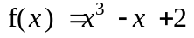 as x
approaches 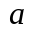 = 2. You may use two tables to investigate the right and left limits individually (as above), or you might want to combine all the necessary information in one table. Either way, your table(s) should have at least nine values for and be labeled as in the above demonstration.

b) Use your table(s) in part (a) to approximate a number so that, for =0.1,
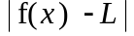< whenever <

2. a) Repeat part (a) from problem number 1 for the following limit:
(Note that the is entered in Maple as "sqrt(x)").

b) Based on your table, estimate the limit in part (a) to the nearest hundredth.

c) Repeat part (1b), with = 1 and L equal to your estimate of the limit that you
found in part (2b).
Lab 4: Evaluating Limits in Maple

Goals
1. Students will use Maple to evaluate two-sided limits, one-sided limits, and limits at infinity.
2. Students will use Maple to find vertical and horizontal asymptotes.

Discussion
Maple can compute various types of limits. It can evaluate limits from both positive and negative directions. Moreover, Maple recognizes undefined limits.

Limits

Finite and Infinite Values

Maple not only computes the limit of a function as x approaches a finite value but also as x goes to infinity, as shown in the following example.

> f:= (2*x+3)/(7*x+5);

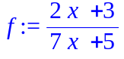
> Limit(f, x=infinity );

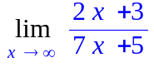
> value(%);

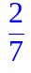
Note the capital "L" on the limit command gives an output of the limit in mathematical notation, which allows you to make sure you entered the correct limit. To find the value of the limit, we employed the the value command. Use a lower case "l" on the limit command as follows to find the value of the limit in one step.

> limit(f, x=infinity );

Note that 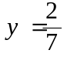 is a horizontal asymptote of 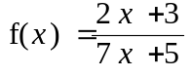. Also observe that the following graph of f seems to verify that the horizontal asymptote is indeed . Finally, note that although Maple plots the vertical asymptote of 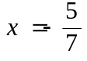 , it does not include the horizontal asymptote .

> plot(f(x),x=-10..10,y=-5..5);
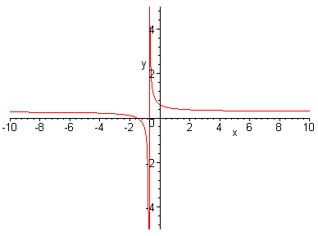

Positive and Negative Directions
You can also take the limit of an expression from both the positive and negative directions. Consider .

> Limit( tan(x+Pi/2), x=0, left);

> value(%);

> Limit( tan(x+Pi/2), x=0, right );

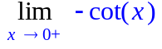

> value(%);

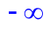
Note that 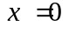 is a vertical asymptote of 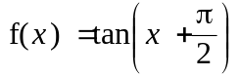. The below graph verifies this result.

> plot(tan(x+Pi/2),x=-5..5,y=-5..5);

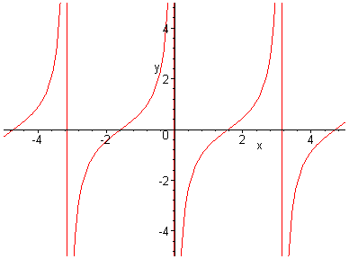

Also, since the left-hand limit and the right-hand limit are not equal, 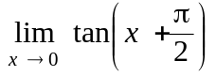 does not exist, as the following commands demonstrate.

> Limit( tan(x+Pi/2), x=0);

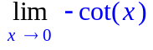

> value(%);

Finally, Maple can compute limits involving absolute values. Consider .
> Limit( abs(x-4)/(x-4) , x=4, right );

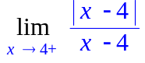
> value(%);

Lab Assignment 4

Start the lab by putting your name on the first line. Do the assignment in a new file (go to the file menu in Maple and click on "New"). Copy the below questions to your new file. When you complete the lab, hand in a printout of it. ANSWER ALL QUESTIONS COMPLETELY IF YOU WANT FULL CREDIT!!!

1. a) Use Maple to find the following limit: .

b) Graph the function using the plot command. Does the graph seem to verify the
limit that Maple gave you? Why or why not?

c) Does the function have a vertical asymptote? If so, what is it?

2. Use Maple to verify that 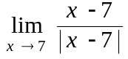 is undefined. Find the left and right limits of
the function using Maple. Use these results to explain why the function is undefined.

3. a) Use Maple to evaluate the following limit:

b) Use the plot command to graph . Consider the behavior of the

graph as x goes to negative infinity. Does this graph seem to verify your answer
in part (a)? Why or why not?

4. a) Use Maple to evaluate the following limits: and
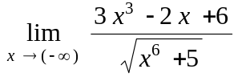

b) What are the horizontal asymptotes associated with the above limits? Graph
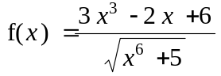 to justify your answer visually.

Lab 5: Secant and Tangent Lines

Goals
Students will investigate the derivative of a function numerically, graphically, and algebraically.

Discussion
We will use Maple to compute slopes of secant lines and use the limiting process to obtain the slope of the tangent line at a point on a curve. We will graph some secant lines and a tangent line of a curve. We will have Maple do the algebraic steps in the definition of the derivative.

Secant and Tangent Lines
Suppose f(x) is the following function.
> f:=x->x^3+x+1;

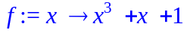

> a:=1;

> f(a);

The point (a, f(a))=(1, 3) is a point on the curve y = f(x). Let Q(x, f(x)) be another (different) point on the curve . The slope of the secant line is defined as follows.
> mPQ:=x->(f(x)-f(a))/(x-a);

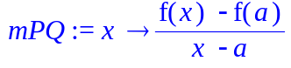

Let's make a table (spreadsheet) of some values for the slopes, mPQ, when x approaches a = 1. Let h = x-a.

 | A | B | C
1 | 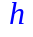 | 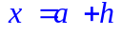 | 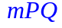
2 | 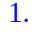 | 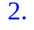 | 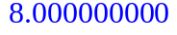
3 | 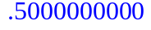 | 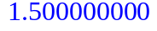
4 |  |  | 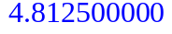
5 |  |  | 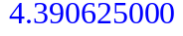
6 |  | 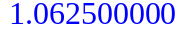
7 |  | 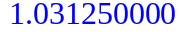
8 |  | 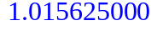 | 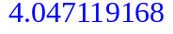
9 | 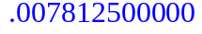 | 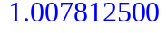 | 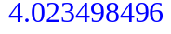
10

From the right column of the table it appears that the right-hand limit of mPQ is 4. Let's make a table for the left-hand limit.

 | A | B | C
1
2 | 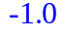 | 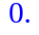 | 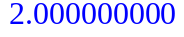
3 |  |  | 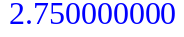
4 | 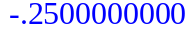 |  | 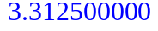
5 | 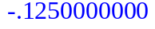 | 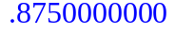 | 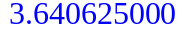
6 | 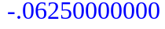 | 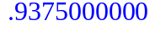 | 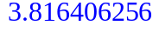
7 |  |  | 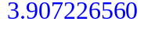
8 | 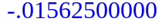 | 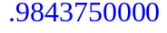 | 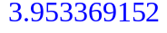
9 | 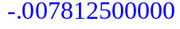 | 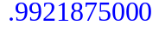 | 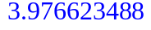
10 | 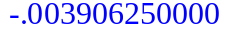 | 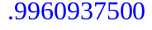 | 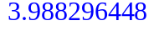

The tables indicate that there is a two-sided limit for the slopes of the secant lines. This limit is the slope of the tangent line.
> m:=limit(mPQ(x),x=1);

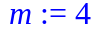

Let's graph the function with the tangent line and the secant lines for x = 2, 1.5, and 1.25.
> t:=x->m*(x-a)+f(a);

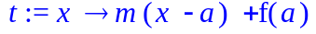

> s1:=x->mPQ(2)*(x-a)+f(a);

> s2:=x->mPQ(1.5)*(x-a)+f(a);

> s3:=x->mPQ(1.25)*(x-a)+f(a);

> plot([f,t,s1,s2,s3],0..2,color=[black,red, green,blue, pink]);

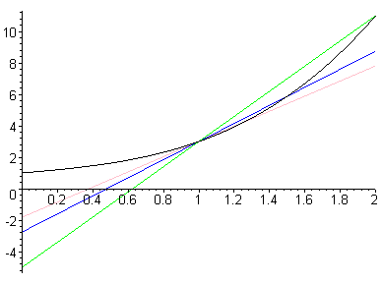

Difference Quotients
The definition of the derivative of the function f(x) at the point x = a is given by
f '(a)=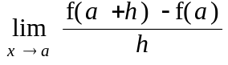. The derivative is also the slope of the tangent line to the curve y = f(x) when x = a. The slope of a secant line is 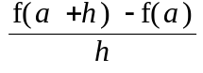 and is called a difference quotient. In the following example Maple calculates the slopes for some secant lines and the slope of the tangent line.
> f:=x->1/(2*x+3);

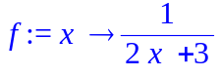

> a:=1;

> (f(a+h)-f(a))/h;

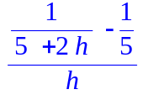

> simplify(%);

> dq:=unapply(%,h);

dq is the difference quotient (defined as a function) for our function f(x). Notice that Maple will do algebra - it will simplify the difference quotient. Let's use dq to calculate slopes of some secant lines as x approaches 1. First, use x = 1.5, 1.1,and 1.01. The corresponding h-values, h = x-1, are 0.5, 0.1,and 0.01, respectively.
> dq(0.5); dq(0.1); dq(0.01);

Next we will try some x's left of 1, use x = 0.95, 0.99, and 0.999. The corresponding h-values are -0.05, -.01, and -.001, respectively.
> dq(-.05); dq(-.01); dq(-0.001);

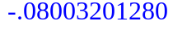

Let's compare our calculations with Maple's limit of the dq's as h approaches 0.
> limit(dq(h),h=0);

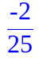

> evalf(%);

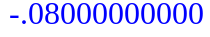

Maple will graph the function and the tangent line on the same graph.
> with(student):
> showtangent(f(x),x=1,x=-1..3);

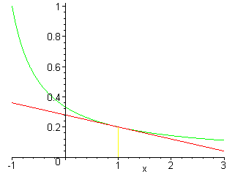
Lab Assignment 5

Start the lab by putting your name on the first line. Do the assignment in a new file (go to the file menu in Maple and click on "New"). Copy the below questions to your new file. When you complete the lab, hand in a printout of it. ANSWER ALL QUESTIONS COMPLETELY IF YOU WANT FULL CREDIT!!!

For each function f in numbers 1 and 2 below, do parts (a)-(f)
a) Find f(a)
b) Define the difference quotient (using h's) at the given point, a.
c) Find the slopes of the secant lines at the given point by using the difference quotient with h = 0.1, 0.01, 0.001, -0.01, and -0.001.
d) Find the slope of the tangent using the limit as h approaches zero.
e) Write a function for the secant line when h = 0.5 and a function for the tangent line.
f) Make a graph that contains the function, the secant line for h=0.5, and the tangent
line. Be sure to choose the screen size so that these three curves can be
distinguished. Note: the printer does not print yellow curves.

1. f(x) =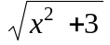 with a = 1

2. 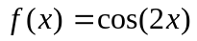 with 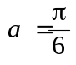
Lab 6: Derivatives in Maple

Goal
Students will find and evaluate derivatives using Maple.

Discussion
In this lab you will use Maple to take derivatives of mathematical functions defined both as Maple expressions and as Maple functions.

Differentiation
It should be no surprise that Maple can compute derivatives for you. To introduce this idea, we will work with the following function: 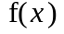= 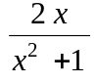. One way to find a derivative is to use the diff command as follows.

> diff((2*x)/(x^2+1),x);

To input the above function as a Maple expression, type in the following.

> f:=(2*x)/(x^2+1);

To find the derivative of the Maple expression, f, again use the diff command.

> diff(f,x);

Use the simplify command to transform the above output into single rational expression as follows.

> simplify(%);

Note that diff(f,x) is an expression. Let’s give it a name.
> Df:=diff(f,x);

To evaluate the derivative of f at x = 2.5, use the eval command as follows.
> eval(Df,x=2.5);

If f is defined as a Maple function (as opposed to defining f as an expression in Maple), then the commands for taking and evaluating derivatives are different. In the following examples, we define f as a function in Maple and redo some of the above work using the command structure for Maple functions.

> f:=x->(2*x)/(x^2+1);

To take the derivative of a Maple function, type the following command.

> D(f);

Note that D(f) is a function. To evaluate the derivative of f at 2.5 type the following.

> D(f)(2.5);

Finally, note that the equation of the tangent line to f at the point (2.5, f(2.5)) is . The next example plots both f and the tangent line to f at (2.5, .f(2.5))

> plot([f(x),-.1997621878*(x-2.5)+f(2.5)],x=0..5,y=-1..1.5,color=[red,blue]);

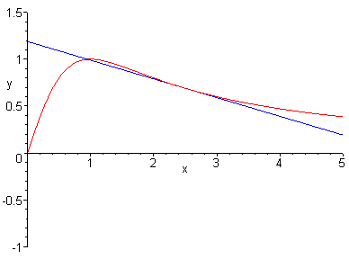
Lab Assignment 6

Start the lab by putting your name on the first line. Do the assignment in a new file (go to the file menu in Maple and click on "New"). Copy the below questions to your new file. When you complete the lab, hand in a printout of it. ANSWER ALL QUESTIONS COMPLETELY IF YOU WANT FULL CREDIT!!!

1. Define in Maple as a MAPLE FUNCTION.
a) Use Maple to find an equation of the tangent line to this curve at the point (1, 1).
Remember to use the D syntax to take the derivative of f (Hint: Although the
derivative that Maple comes up with will look unfamiliar to you, keep in mind that all you have to do to find the slope of your tangent line is to evaluate the derivative at x = 1 ).

b) Plot the equation along with the tangent line that you found in part (a) on the same
graph.

2. Find the derivative of using Maple and apply the simplify
command on the result (Hint: use the diff command to take the derivative otherwise Maple will not simplify it).

a) Plot the above function and its derivative on the same plane. Describe the behavior of the function f that corresponds to any zeros of the graph of the derivative (i.e. discuss what happens to the graph of f as the graph of the derivative of f crosses the x-axis).

b) For which x-values does the graph of f have horizontal tangents?

c) Use the eval command (and the x-values from part (b)) to locate the y-values at
which f has horizontal tangents.

3. The equation measures the resistance R (in ohms) of a
certain resistor at temperature T degrees Celsius.

a) Plot the function R and use this graph to estimate the temperature at which this type of resistor has minimum resistance and the minimum resistance itself. Be sure to record both your estimates.

b) Note that, according to your graph from part (a), the derivative of R appears to be
zero at the temperature T for which R reaches a minimum (since the graph of R has a horizontal tangent at this T value). Thus, one way to find a more exact value of T at which R reaches a minimum is to set the derivative of R equal to zero and solve for T. Try this idea using the diff and fsolve commands. (Hint: your answer should be reasonably close to the estimate that you found for T in part (a)).

Lab 7: Implicit Relationships

Goals
1. Students will differentiate implicitly with Maple using the implicitdiff command.
2. Students will graph non-functions using the implicitplot command.

Discussion
A relationship that is not solved for y, but instead has x's and y's intermingled throughout is called an implicit relationship. Occasionally these are functions, but more often they are not. In this lab we will look at implicit relationships, their graphs and derivatives.

Implicit Differentiation
First, use the with(plots) command to load more graphing options into Maple's memory.

> with(plots);

Here's an example of how to plot the equation implicitly using the implicitplot command.

> implicitplot(y^3+y^2-5*y-x^2=-4,x=-5..5,y=-5..5);

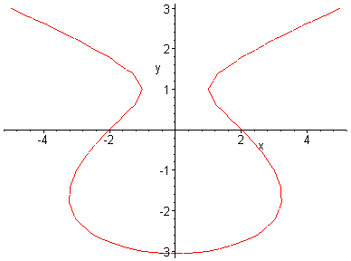

Note that the above equation is not a function because its graph does not pass the vertical line test.
Recall that the derivative of a function is undefined wherever vertical tangents occur. Let's take the derivative and find out exactly where the vertical tangents occur. We use the implicitdiff command as follows.

> implicitdiff(y^3+y^2-5*y-x^2=-4,y,x);

The derivative is undefined when the denominator is zero. Thus, to find y-values where the vertical tangents occur, set the above denominator equal to 0 and have Maple solve this equation as follows.

> solve(3*y^2+2*y-5=0,y);
(Note that we could have solved this equation by hand rather easily.)

To find the x-coordinates that go with these y-coordinates, first set the original equation, equal to zero to get . Then use the subs (or eval) command to evaluate this equation for 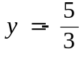.

> subs(y=-5/3,y^3+y^2-5*y-x^2+4=0);

Solve the resulting equation for x to obtain the desired x-values.

> solve(283/27-x^2=0,x);

To get decimal approximations of these x-values, use the evalf command.

> evalf(%);

Next, we repeat the process for .

> subs(y=1,y^3+y^2-5*y-x^2 +4);

> solve(1-x^2=0,x);

So the points where the vertical tangent lines occur are (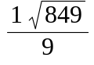 , 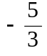), (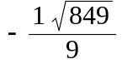 , ), (1, 1) and (-1, 1)
The equations of the associated vertical tangent lines are x = , x = , x =1, and x = -1.

In the final example, we graph the original equation, along with all of its vertical tangent lines.

> implicitplot({y^3+y^2-5*y-x^2=-4,x=1,x=-1,x=3.238,x=-3.238},x=-5..5,y=-5..5);

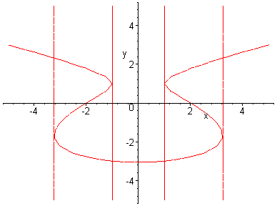

Lab Assignment 7

Start the lab by putting your name on the first line. Do the assignment in a new file (go to the file menu in Maple and click on "New"). Copy the below questions to your new file. When you complete the lab, hand in a printout of it. ANSWER ALL QUESTIONS COMPLETELY IF YOU WANT FULL CREDIT!!!

1. a) Find the point (both the x and y coordinates) at which 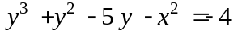 has
a horizontal tangent line using the implicitdiff command (keep in mind that only
real numbers are allowed for the coordinates of a point in the Cartesian plane).

b) Plot both the above equation and its associated horizontal tangent using implicitplot.

2. a) Take the derivative of 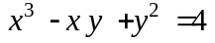 using implicitdiff.

b) Find the equation(s) of the vertical tangent(s) to the curve.

c) Plot the above equation and its associated vertical tangent line(s) using the
implicitplot command.

3. a) Graph the equation . Use your pointer to
estimate the x-coordinates of the points where horizontal tangents occur.

b) Locate the exact x-values of the points where horizontal tangents occur (you
estimated these in part (a)).

c) Find the tangent line equations to the curve at the points (0, 1) and (0, 2).

d) "Play" with the equation in part (a) to design at least two other interesting looking
graphs (i.e. be creative in changing the above curve by throwing in additional exponents or factors to the given equation and graph these new equations).

4. (#34 page 231 of your text).
a) The curve with equation has been likened to a
bouncing wagon. Use a computer algebra system to graph this curve and discover why. [Graph the curve using the implicitplot command. Make sure you plot your graph using an appropriate domain and range so that you can see the "wagon."]

b) At how many points does this curve have horizontal tangent lines? Find the x-
coordinates of these points. [There are actually 9 distinct points with horizontal tangents but only 3 distinct x-coordinates. For instance, 3 points with horizontal tangents occur at x = 0. Can you find the others? In part (b) you will need to plot the graph again, adjusting the domain and range in order to find these tangents. Be sure to find all x-coordinates (there are only 3 distinct ones) of the points with horizontal tangents.]

Lab 8: Linear Approximation and Differentials

Goals
1. Students will approximate functions locally using linear approximations.
2. Students will use the differential dy to approximate.

Discussion
A curve lies very close to its tangent line near the point of tangency. The y-values of the tangent line approximate the values of the function. We will compare some of these values by using a table and by graphing the function and its tangent line. We will also compare some values of dy and .

Linearization

Consider the function f(x)=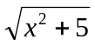. We will find the equation of its tangent line when x = 2.
> f:=x->sqrt(x^2+5);

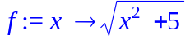
>a:=2;

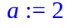
>f(a);

The point (2, 3) is on the curve y = f(x). The tangent line, or linearization of f at x = a, is given by the equation 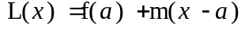 where m is the derivative evaluated at
x = a. We need to find the derivative and then determine m.
> D(f);

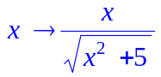

> m:=D(f)(a);

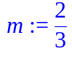

> L:=x->f(a)+m*(x-a);

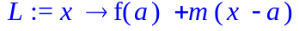
> plot({f,L},0..4);

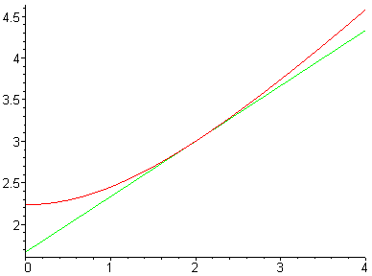

On the above graph, the curve f and the linearization L appear close for x-values near 2. Next we will compare the values of f(x) and L(x) for some of x-values near 2.
>
 | A | B | C | D | E
1 | 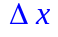 |  | 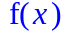 |  | 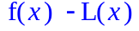
2 |  | 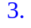 | 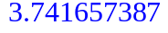 | 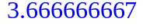 | 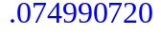
3 |  | 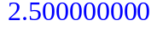 | 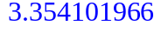 | 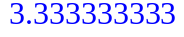 | 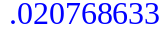
4 |  | 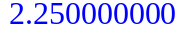 | 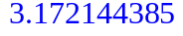 | 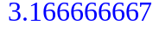 | 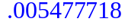
5 |  | 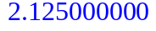 | 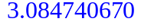
6 |  | 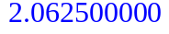 | 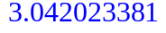 | 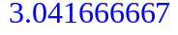 | 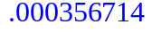
7 | 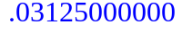 | 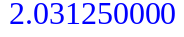 |  | 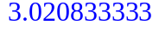
8 | 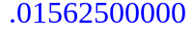 |  |  | 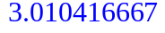 | 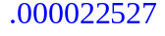

 | A | B | C | D | E
1 |  |  |  | 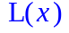
2 |  |  | 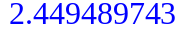
3
4 |  | 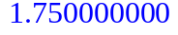 | 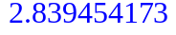 | 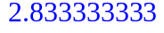
5 |  |  |  | 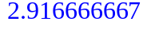 | 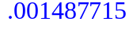
6 |  | 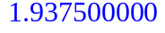 | 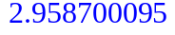 | 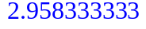
7
8 |  | 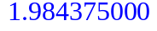 |  |  | 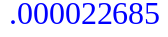

Notice from the above tables that L(x) is a good estimate of f(x) when x is close to a = 2, but the accuracy deteriorates when x is farther away from a = 2. Suppose we want L(x) to approximate f(x) to within 0.01. What x-values can be used? From the right column of the tables above it appears that the x-interval [1.75, 2.25] would keep
< 0.01. Let's see how Maple handles this problem.
> solve(abs(f(x)-L(x))<0.01);

Maple finds a larger open x-interval (1.68, 2.34). Let's reexamine the problem from a graphical view. We want the x-values that make f(x)-0.01< L(x)<f(x)+0.01. We find the x-values that keep the line L between the curves f-0.01 and f+0.01.
> plot([L,f-0.01,f+0.01],1.5..2.5,color=[red,black,black]);

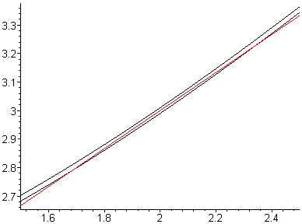

Differentials
Let y = f(x)= and a = 2 again. Let's compare the differential dy = f'(x)dx with y for some x's near a = 2.
> f:=x->sqrt(x^2+5);

> a:=2;

> f(a);

> D(f);

> m:=D(f)(a);

> L:=x->f(a)+m*(x-a);

 | A | B | C
1 |  | 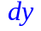 | 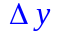
2 | 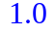 | 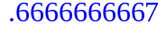
3
4 |  | 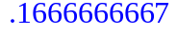 | 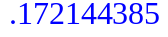
5 |  | 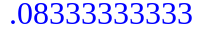 | 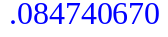
6
7
8

 | A | B | C
1
2 |  | 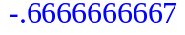
3 | 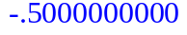
4 |  |  | 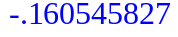
5
6 |  | 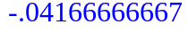 | 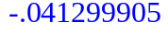
7 |  | 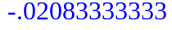 | 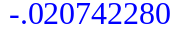

Notice dy and 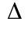y are close when is small. How small must be before is at most 0.1 ? Estimate by using the two above tables. It appears that the computation of y will be accurate to within 0.1 when the error, , in x is no more than 0.125.

Consider the following application of the differential.
The side of a cube was found to be 5 cm with a possible error in measurement of 0.1 cm. We wish to estimate the possible error in computing the volume of the cube by using the differential. Let x be the length of a side of the cube; so x is between 5 - 0.1 = 4.9 and 5+0.1=5.1.
> V:=x->x^3;

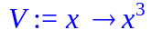

> m:=D(V)(5);

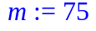

> dV:=dx->m*dx;

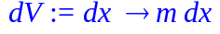

> dx:=0.1;

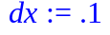

> dV(0.1);

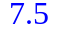

> V(5);

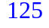

Using the differential we estimate that the volume is 125 with a maximum error of of 7.5; we estimate that the volume is between 125-7.5=117.5 and 125+7.5=132.5.
Instead of using the differential let's consider V. Let's find the maximum of 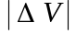 on [4.9, 5.1] by graphing.

> plot(abs(V(x)-V(5)),x=4.9..5.1,y=0..8);
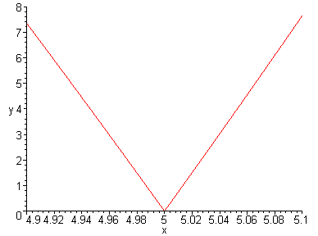

It appears that the maximum of is 7.65, only slightly more than our estimate obtained by using differentials.

Lab Assignment 8

Start the lab by putting your name on the first line. Do the assignment in a new file (go to the file menu in Maple and click on "New"). Copy the below questions to your new file. When you complete the lab, hand in a printout of this page with the blanks filled in and a printout of your Maple worksheet. ANSWER ALL QUESTIONS COMPLETELY IF YOU WANT FULL CREDIT!!!

1. Let f(x) = 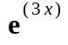 (= exp(3*x) in Maple) and a = 0.

a) Find the linearization L(x) at a=0.

b) Create two tables using Maple's spreadsheet, one starting with = 0.2 and
the other starting with = -0.2. Each table should have at least 10 rows and 5 columns with headings x f(x) L(x) f(x)-L(x)
Note that x = since a =0.

c) Estimate the x-values, in interval notation, where the linearization L(x)
is within 0.05 of f(x); tell where 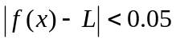.
_________________

d) Plot the curves L, f+0.05, f-0.05 using x-values in [-0.2, 0.2].

2. The radius of a sphere was measured to be 5 with a possible error of 0.1.

a) Use differentials to estimate the maximum error in the
calculated volume, V, of the sphere. dV=______________

b) Plot for radii in [4.9, 5.1]. Then estimate the
maximum for the graph. maximum = _____________

c) Use differentials to estimate the maximum error in the
calculated surface area, A, of the sphere. dA=______________

d) Plot 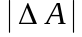 for radii in [4.9, 5.1]. Then estimate the
maximum for the graph. maximum =______________

LAB 9: Graphing Using Derivatives

Goals
1. Students will use the zeros of the first derivative to find the local maximums
and minimums of a function f.
2. Students will use the zeros of the second derivative to find the inflection points
of a function f .

Discussion
The first and second derivatives of a function f determine some of the properties of f. Local maximums and minimums of f occur at the zeros of the first derivative. The inflection points of f occur at the zeros of the second derivative. Maple will be used to find the derivatives. The graphs of f and its derivatives will be compared.

Example
Consider the following function, defined as an expression in Maple.
> f:=x^2*exp(x);

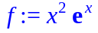

Next we will calculate the first derivative and call it Df. Then we will factor the first derivative to find the critical values of f.
> Df:=diff(f,x);

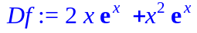

> factor(Df);

> solve(Df=0,x);

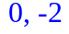

These are x-values. We want the corresponding y-values.
> subs(x=-2,f);

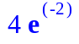

> evalf(%);

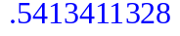

> subs(x=0,f);

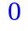

> plot([f,Df],x=-4..4, y =-2..2,color=[black,red]);

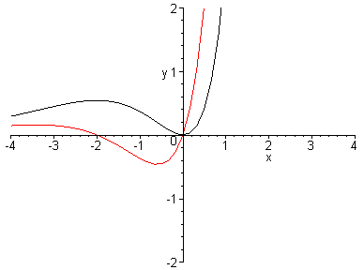

Which graph is f? Which is the graph of the derivative of f ? Compare the x-intercepts of the derivative function with the x-values of the local maximums and minimums of f
Now we will find the second derivative.
> D2f:=diff((Df),x);

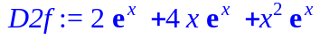

> factor(%);

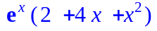

The following command is another way to find the second derivative of the expression f .
> diff(f,x$2);

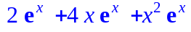

Next, we find what some books call the "second order critical values". To do this, set the second derivative equal to 0 and solve in order to find the x-coordinates of possible inflection points.
> a:=solve(D2f=0,x);

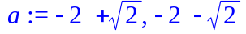

> evalf(%);

These x-values are called a[1] and a[2]. Now we obtain the corresponding f(x)-values and graph the second derivative along with the original function.
> subs(x=a[1],f);

> evalf(%);

> subs(x=a[2],f);

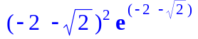

> evalf(%);

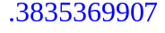

> plot([f,D2f],x=-5..5,y=-1..3,color=[black,green]);

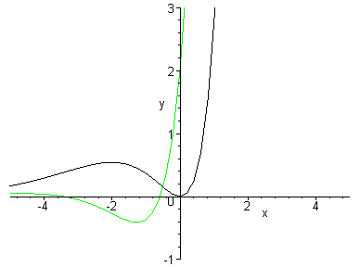

Compare the x-intercepts of D2f with the x-values of the inflection points of f on the graph. Where is f concave up? concave down?
Finally, it appears that f may have a horizontal asymptote on the left. Let's check.
> limit(f,x=-infinity);

0

So y = 0 is a horizontal asymptote of f.

Lab Assignment 9

Start the lab by putting your name on the first line. Do the assignment in a new file (go to the file menu in Maple and click on "New"). Copy the below questions to your new file. When you complete the lab, hand in a printout of this page with the blanks filled in and a printout of your Maple worksheet. ANSWER ALL QUESTIONS COMPLETELY IF YOU WANT FULL CREDIT!!!

1. Consider the function 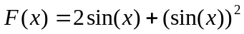 on the interval 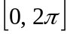

a) Find the first derivative of F. Then graph F and F' on the same graph.

b) Find all the critical numbers of F in the interval .
Hint: Did Maple's solve command find all the critical numbers
(look at the graph)? You need to help Maple locate one of the
solutions by using fsolve(F'=0, x=a..b) where [a, b] is the
interval that contains the desired solution. What
are the critical numbers for F? _______________________

c) Find the second derivative of F. Then graph F and F" on the same graph.

d) What are the inflection points, (x, F(x))? _______________________

e) Find the points, (x, F(x)), that are local maximums _____________________

or local minimums of F __________________________.

2. Consider the function on the interval [-1, 6].

a) Find the first derivative of F. Then graph F and F' on the same graph.
Be sure to choose the y-values of the screen's dimensions so that the
extreme values of F and the zeros of F' are clearly visible.

b) What are the critical numbers for F?______________________________

c). Find the second derivative of F. Then graph F and F" on the same graph.

d) What are the inflection points (x, F(x))?____________________________

e) Find the points (x, F(x)) that are local maximums ____________________,

local minimums______________, an absolute maximum ______________

and an absolute minimum ________________

3. Let's go fly a kite! Your job is to maximize the area of the kite so that it will fly
better, faster, higher. To do the following problems, refer to the picture below.

x

a
a
y

x

z

b
b

a) Let a = 12 inches and b = 18 inches. Find x, y and z so that the area of the kite
is a maximum. Use Maple to develop the solution to this problem and write up
your response. (Hint: express y and z in terms of x using the Pythagorean
theorem. Find a function that represents the area of the kite, in terms of x and
maximize that function.)

b) Now find x, y, and z for the general case (a=a and b=b). Your answer should
have x, y, and z in terms of a and b. Use your answer to check part (a) and to
find x, y, and z for a = 15 and b = 21.

Lab 10: Numerical Integration

Goal
Students will approximate the area under a curve and evaluate definite integrals using Riemann sum approximations and limits.

Discussion
Consider the area bounded by a continuous function y = f(x), the x-axis, and vertical lines x = a and x = b. Usually there is not a simple formula for such an area. The area can be approximated by a sum of rectangles, a Riemann sum. The approximation will be closer to the desired area when a large number of small rectangles is used. Maple will be used to do the numerical computations for the Riemann sums. The limit of the Riemann sums will also be considered.

Area Example
We are going to approximate the area bounded by the curve f(x) = 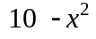, the x-axis, and the vertical lines x = 1 and x = 3.
> f:=10-x^2;

To run the commands for approximations Maple requires the loading of one of its library packages.
> with(student);

We will have Maple divide the interval [1,3] into n = 4 equal subintervals of length 1/2 and approximate the area under the curve with rectangles using the right endpoints.
> rightbox(f,x=1..3,4);

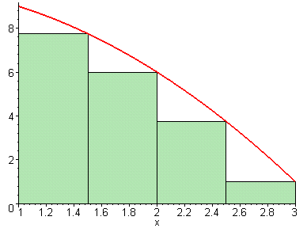

> rightsum(f,x=1..3,4);

> evalf(%);

This is the sum of the areas of the inscribed rectangles. This number is clearly smaller than the desired area. Now you redo the above commands using more rectangles: replace n = 4 with n=20. Then redo the commands with n =50, then n=100. What is the limit of the areas as n gets larger?
> limit(rightsum(f,x=1..3,n),n=infinity);

Next we will approximate the area using n=4 with the left endpoints.
> leftbox(f,x=1..3, 4);

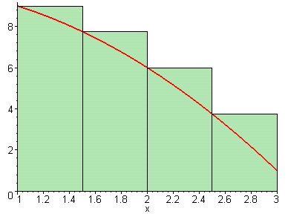

> leftsum(f,x=1..3,4);

> evalf(%);

This is the sum of the areas of the circumscribed rectangles; it is larger than area under the curve y = f(x). Now you redo the above commands using more rectangles: replace
n = 4 with n=20. Then redo the commands with n= 50, then n=100. What is the limit of the areas as n gets larger?
> limit(leftsum(f,x=1..3,n),n=infinity);

We will do more approximations.
> middlebox(f,x=1..3,4);

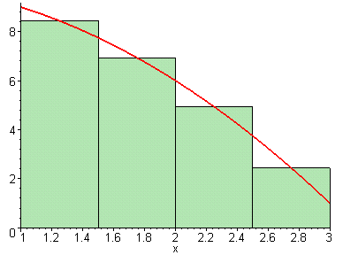

> middlesum(f,x=1..3,4);

> evalf(%);

Now you redo the above commands using more rectangles; replace n= 4 with n=20. Then redo the commands with n=50, then n=100. What is the limit of the areas as n gets larger?
> limit(middlesum(f,x=1..3,n),n=infinity);

Note that the limits from rightsum, leftsum, and middlesum are all the same. This is the area bounded by the curve, the x-axis, and the vertical lines x = 1 and x = 3. It is denoted by 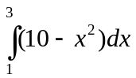. . Below is Maple's command to evaluate this definite integral.
> int(f,x=1..3);
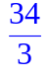

Riemann Sum Example
The definite integral 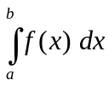 is defined as 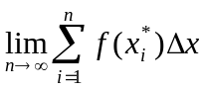, where the interval
[a, b] is subdivided into n equal subintervals and is a point in the subinterval. This definition does not depend on whether the function is positive or negative. We can use Maple to evaluate Riemann Sums and limits without considering whether the result is an
area.

Consider the integral 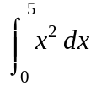. Although this integral represents the area between the x-axis and the graph of 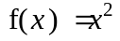 on the interval [0,5], we will evaluate it using sums and limits. Using 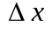 =5/n and right endpoints 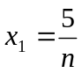, 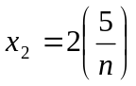,…,,…the integral can be represented by 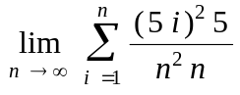. To evaluate the sum portion of this expression, use the following commands.
> Sum((5*i/n)^2*(5/n),i=1..n);

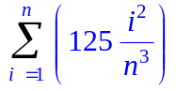
> value(%);

Now, to evaluate the limit, use the following commands.
> limit(%,n=infinity);

To evaluate the limit of the sum all at once, use the following commands.
> limit(Sum((5*i)^2/(n^2)*5/n,i = 1 .. n),n = infinity);

Let's consider another integral. 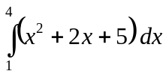.
> f:=x->x^2+2*x+5;

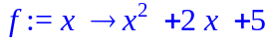

The interval [1,4] is subdivided into n equal subintervals of length = (4-1)/n =3/n. The right endpoints of the subintervals are
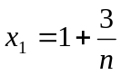, 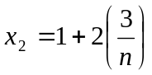 ,…, 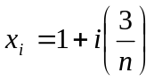,...
> Sum(f(1+i*(3/n))*(3/n),i=1..n);

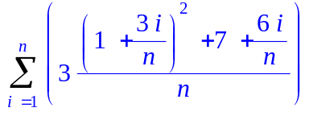

> limit(%,n=infinity);

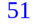

Lab Assignment 10

Start the lab by putting your name on the first line. Do the assignment in a new file (go to the file menu in Maple and click on "New"). Copy the below questions to your new file. When you complete the lab, hand in a printout of it. ANSWER ALL QUESTIONS COMPLETELY IF YOU WANT FULL CREDIT!!!

1. Consider the area of the region R bounded by the graph of f(x) = 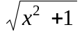,
the x-axis, and the vertical lines x = 0 and x = 6.

a) Use rightbox to obtain a graph of f(x)= together with n = 4
rectangles. Then use rightsum to calculate the area inside the 4 rectangles.

b) Determine the terms that occurred in the area in part (a), using n = 4 and right
endpoints, by completing the following table - a Maple spreadsheet.
Hint: If you have f defined as an expression, consider making f into
a function before you do the spreadsheet.

 | A | B | C
1 |  |  | 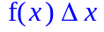
2
3
4
5 |  | 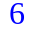

Find the sum of the entries in the right column. The sum should be the same as
the area in part (a).

c) Use rightsum to calculate the area inside the rectangles for n = 10, 20, and 30.
Recall that the rightsum command uses expressions.
Estimate the limit as .

d) Use leftbox to graph f(x) together with n = 4 rectangles. Then use
leftsum to calculate the area inside the 4 rectangles.
e) Determine the terms that occurred in the area in part (d), using n = 4
and left endpoints, by completing the following table - a Maple spreadsheet.

 | A | B | C
1
2
3
4
5

Find the sum of the entries in the right column. The sum should be the same as
the area in part (d).

f) Use leftsum to calculate the area inside the rectangles for n = 10, 20, and 30.
Estimate the limit as n increases.

g) Use Maple's int to find the area.

2. Use the Riemann Sum limit definition to investigate 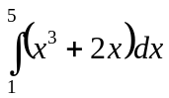.
by entering the Riemann Sum as sum( ________________ ,i=1..n)
followed by limit(______________ , n=infinity)

a) using right end points.

b) using left end points.

Lab 11: Integration in Maple

Goals
1. Students will use Maple to integrate functions.
2. Students will define a function using the Fundamental Theorem of Calculus and investigate its properties using Maple.

Discussion
Maple has the ability to evaluate indefinite and definite integrals using the Int command. In this lab we will use Int to find formulas for antiderivatives and to calculate both exact and approximate values of definite integrals.

Integration
The Int command can be used to find indefinite and definite integrals. To evaluate the indefinite integral 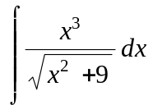, use the Int command as follows.

> Int(x^3/sqrt(x^2+9),x);

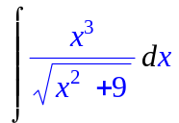
> value(%);

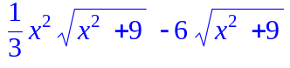

Note: Maple does not add the constant "c" after it finds an indefinite integral (a.k.a. antiderivative). However, you should add the constant in your final answer. Also observe, in the example below, that the upper case "I" in Int can be replaced with a lower case "i" so that Maple directly evaluates the integral, and thus bypasses the need to use the value command.

> int(x^3/sqrt(x^2+9),x);

Next, we give an example of how to evaluate the definite integral .
> Int((tan(x))^5*sec(x),x=0..Pi/3);

> value(%);

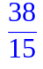

Note: Without the use of Maple, we do not currently know how to perform the integration in the last two examples.

Finally, some functions do not have antiderivatives that can be written using elementary formulas. For example, no elementary antiderivatives exist for 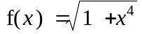 and 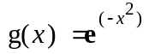. But we can still approximate the value of a definite integral involving these kinds of functions using Maple. In the next example, the evalf command is employed in conjunction with Int to evaluate 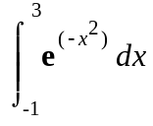.

> Int(exp(-x^2),x = -1 .. 3);

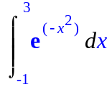

> evalf(%);

The Fundamental Theorem of Calculus
One part of the Fundamental Theorem asserts that = (where f is continuous on [a, b] and x is in [a, b]). Said another way, the rate of change of a definite integral with respect to a variable upper limit is precisely the value of the integrand evaluated at the upper limit.

As previously discussed, some functions do not have antiderivatives that can be written using elementary formulas. For instance, the antiderivative of the function 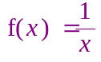 cannot be represented using a nice algebraic formula. But that doesn't mean an antiderivative doesn't exist. In fact, as we already know, the antiderivative of 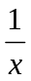 is 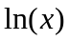 (which is not an algebraic function). We can use the above Fundamental Theorem to define the antiderivative of any function f so long as f is continuous on the interval in question. So, for example, an alternate way to define the antiderivative of 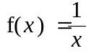 is to set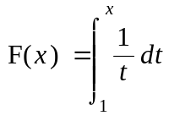 for x > 0 (Note that F is a function of x, not t. Remember that the definite integral is not a function of its variable of integration.) Let's say we want to find 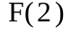. We can use Riemann sums to approximate 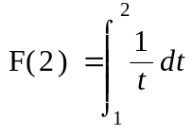 . In the following example, we use 100 subintervals to estimate the value of the integral.

> with(student):

> leftbox(1/t, t=1..2,100, color=blue);

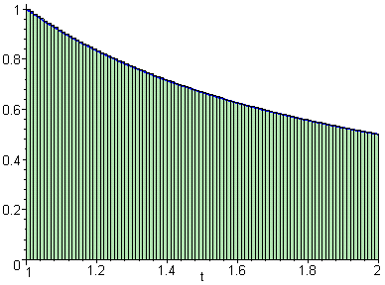
> leftsum(1/t,t=1..2,100);

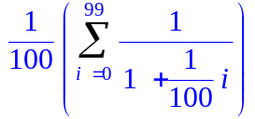
> evalf(%);

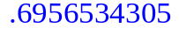

So is about 0.6956534305.
We can also evaluate F to a high degree of accuracy using Maple. First we define F as a function in Maple and then evaluate this function at the desired values.

> F:=x->int(1/t,t = 1 .. x);

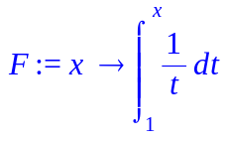
> F(2.0);F(3.5);F(50.0);

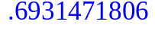
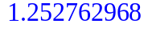
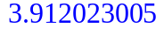

Note that our original estimation of using one hundred subintervals was only accurate to two places past the decimal.

Believe it or not, it turns out that 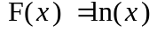. Evaluating 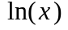 at the same values used in the above example yields exactly the same answers.

> ln(2.0);ln(3.5);ln(50.0);

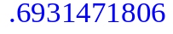
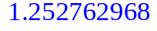
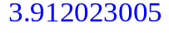

Lab Assignment 11

Start the lab by putting your name on the first line. Do the assignment in a new file (go to the file menu in Maple and click on "New"). Copy the below questions to your new file. When you complete the lab, hand in a printout of it. ANSWER ALL QUESTIONS COMPLETELY IF YOU WANT FULL CREDIT!!!
Be careful to use the asterisk when multiplying.

1. Evaluate the following integrals:
a) 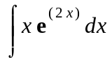 (Hint: use exp(x)=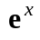)

b) 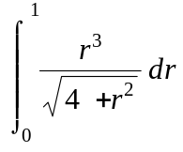

2. The Fresnel function is defined as 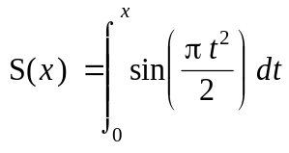 .

a) Define the Fresnel function as a function in Maple. Use int to find decimal
approximations for S(10.0), S(1000.0), and S(10000.0) using Maple. What
number does S(x) appear to approach as x gets bigger? (Note: If you do not
include the decimal point, Maple will not evaluate the function numerically.)

b) Use Maple to find 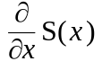 (Since you defined S(x) as a function in Maple, you'll
want to use "D(S)" to find the derivative). Does your answer agree with the
Fundamental Theorem? (Hint: it had better agree.)

c) Plot 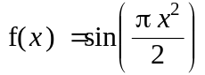 and S(x) together on the interval [0,5] . Graphically, does it appear that could be the derivative of 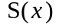? Explain.

d) Does the Fresnel function have a horizontal asymptote? Verify your answer using
the limit command. (Hint: The answer that you obtained at the end of part (a)
should agree with what you get using the limit command.)

e) For which x-values does the graph of S(x) have horizontal tangents? (Hint: it
would probably be easiest to do this one by hand.)

f) Use the graph of the Fresnel function found in part (c) to solve the equation
S(x) = 0.3 correct to one place past the decimal.

g) Use the fsolve command to solve the equation in part (f).

